Screen Design for Super Sighting Database

# Table of Contents

Table of Contents

Table of Contents 1

Home Screen 1

Super Hero/ Villians and Edit Screen 1

Super Powers and Edit Screen 1

Locations and Edit Screen 1

SuperHero Organization and Edit Screen 1

Organizations and Edit Screen 1

Sightings and Edit Screen 1

# Home Screen

The home screen has to show the main layout and a News Feed of the latest 10 items

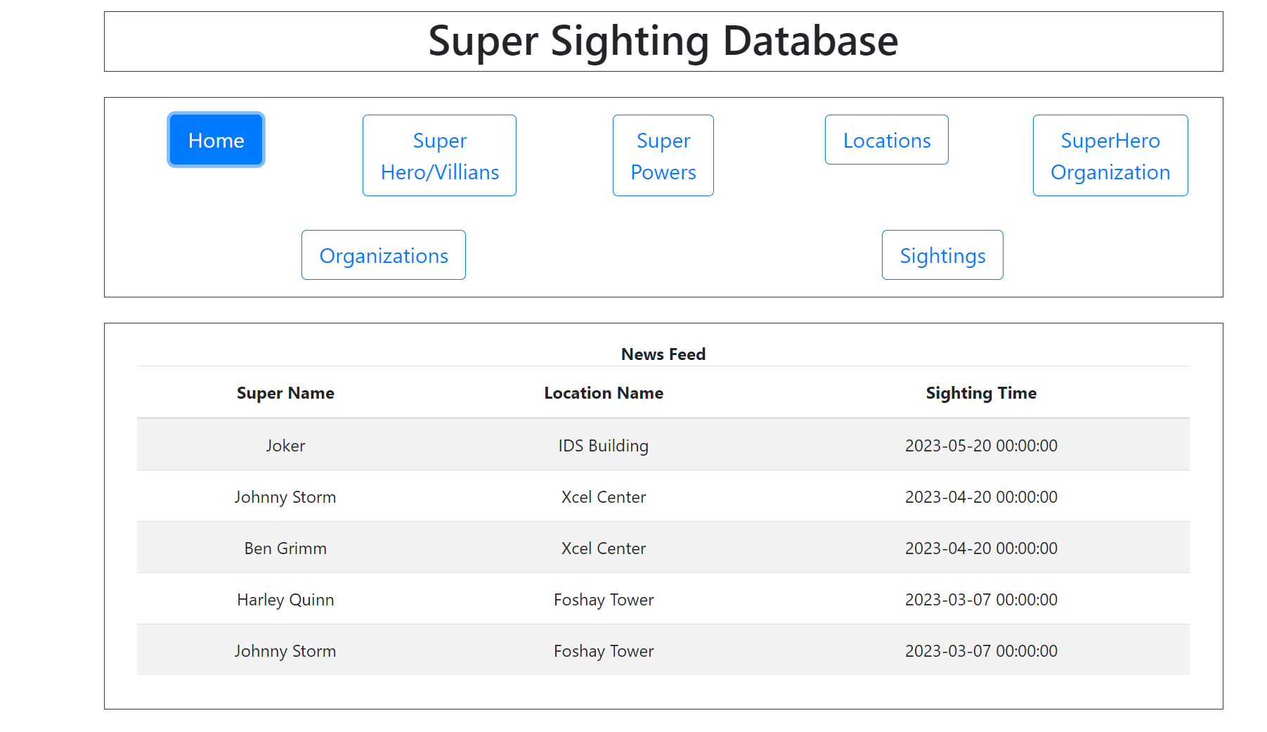

# Super Hero/ Villains and Edit Screen

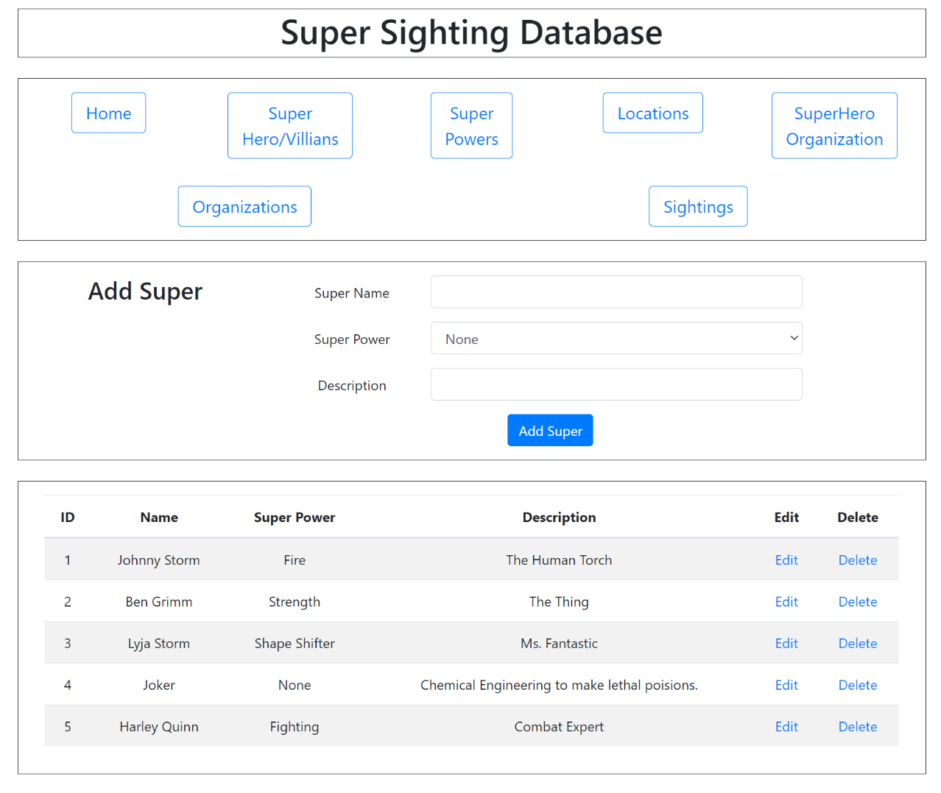

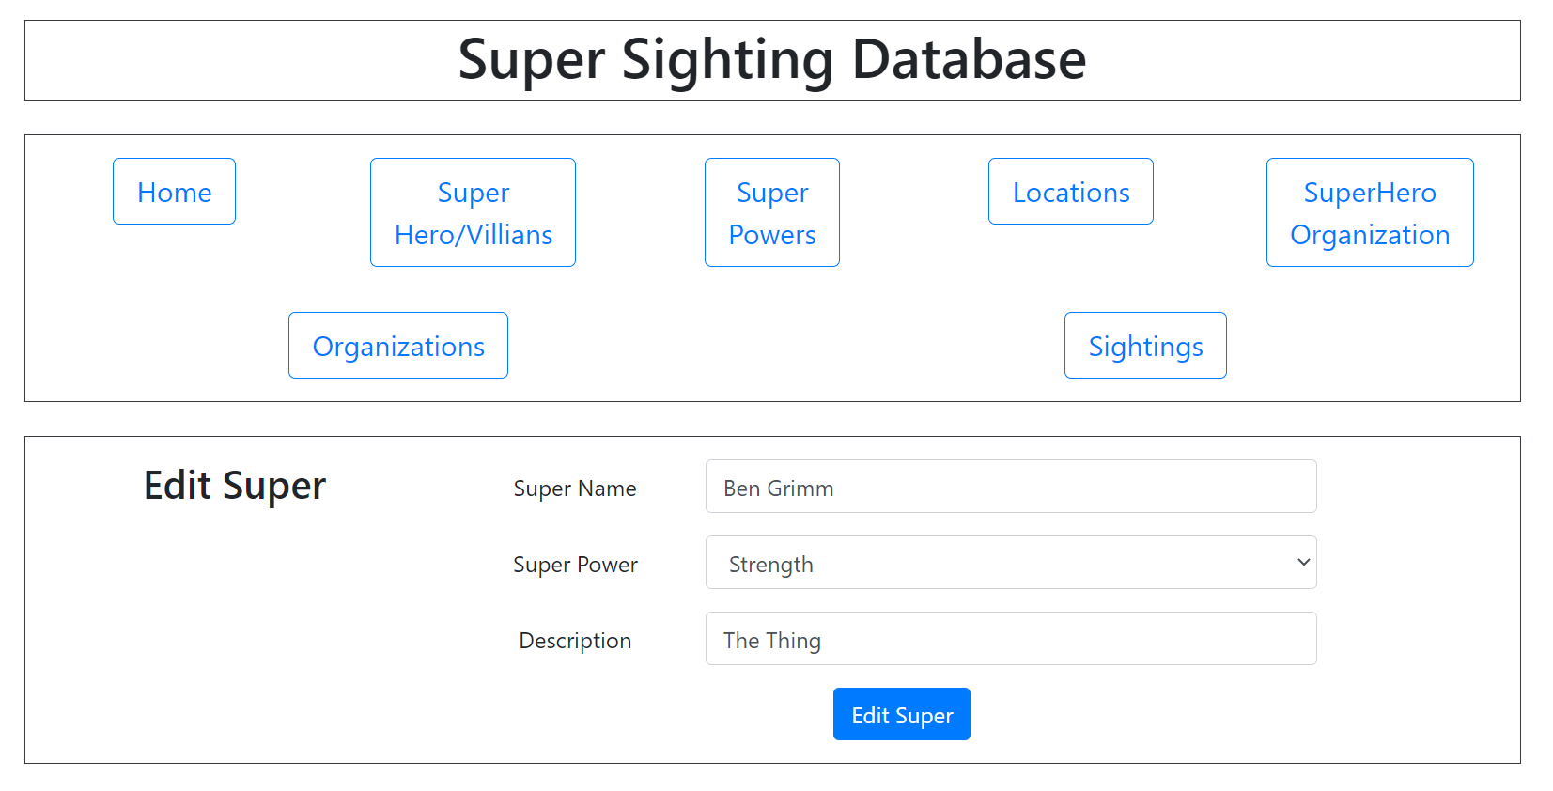

# Super Powers and Edit Screen

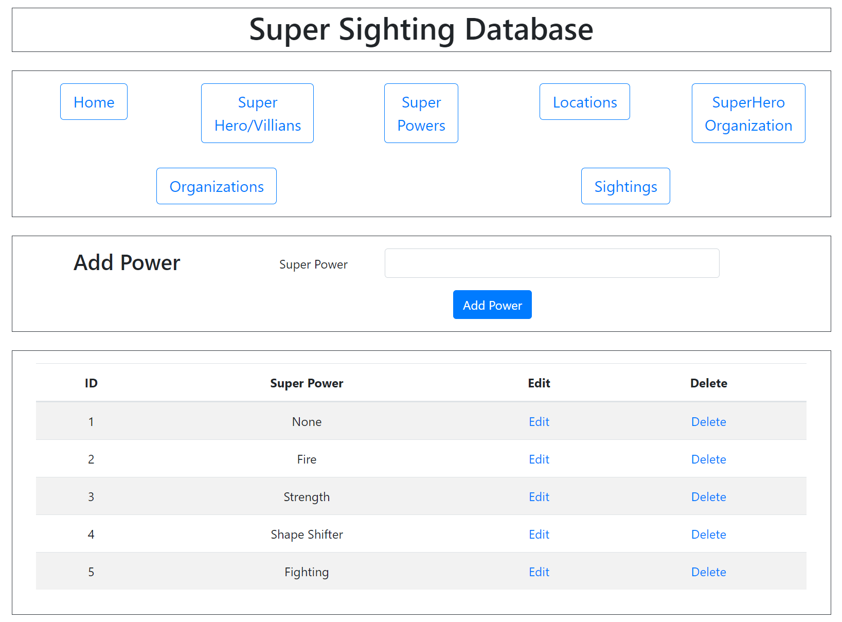

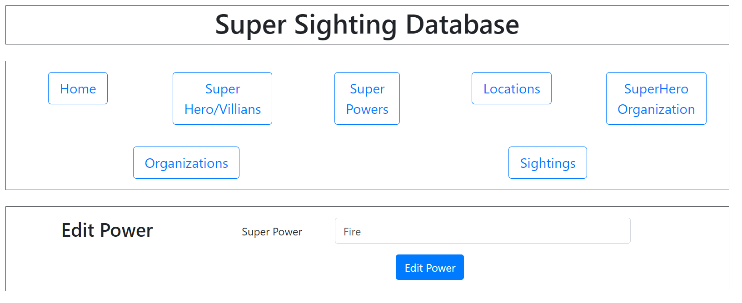

# Locations and Edit Screen

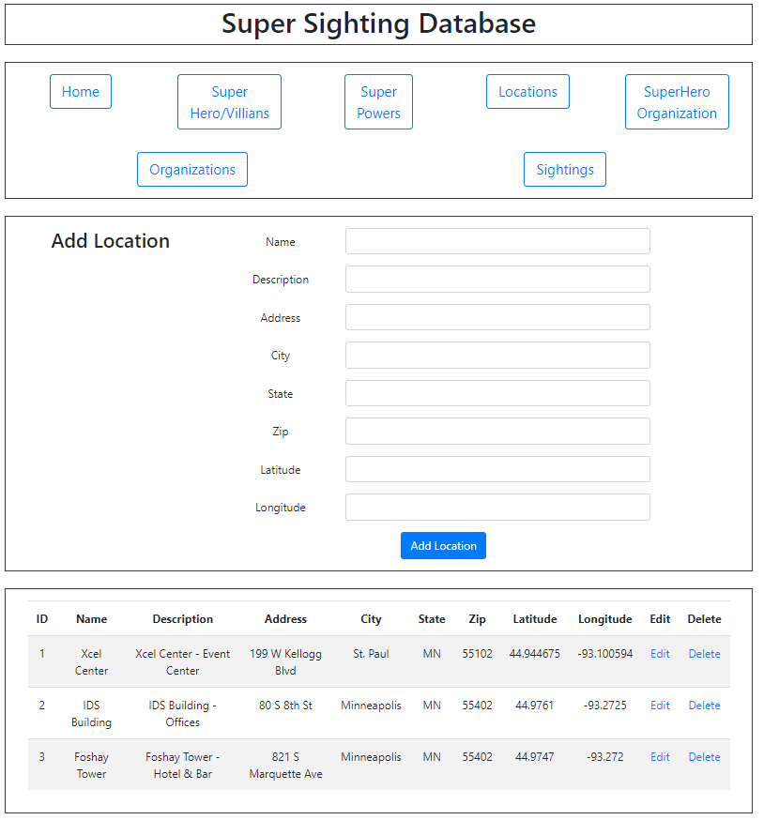

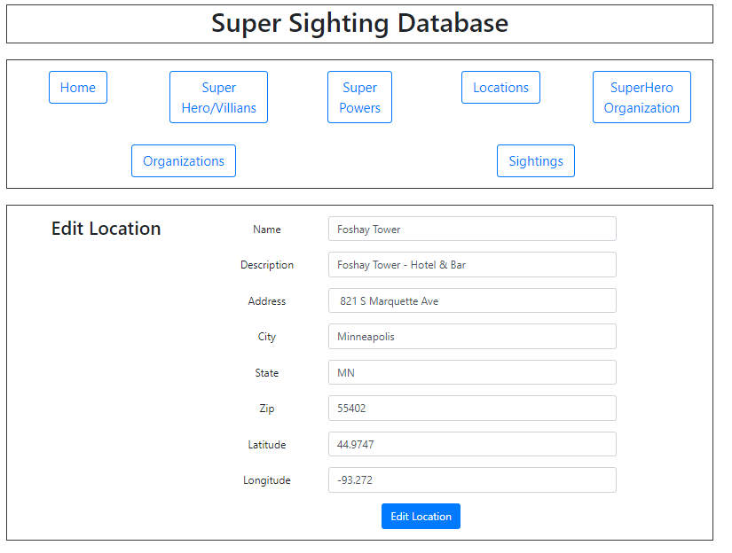

# SuperHero Organization and Edit Screen

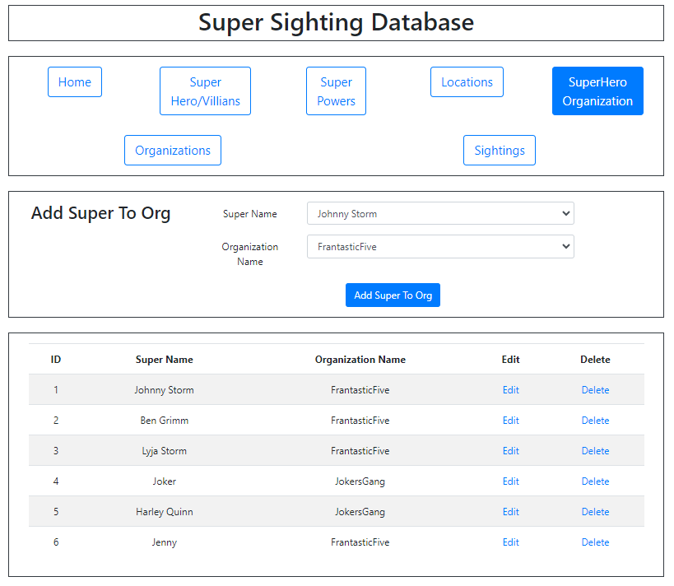

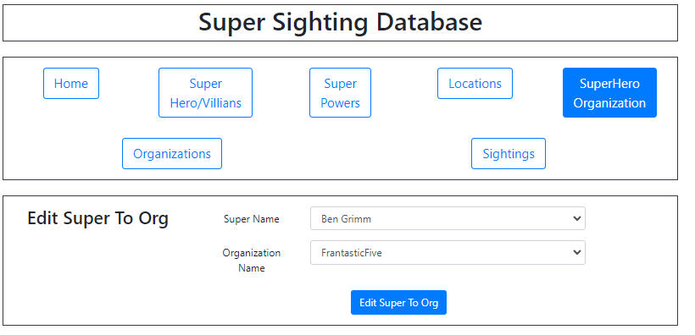

# Organizations and Edit Screen

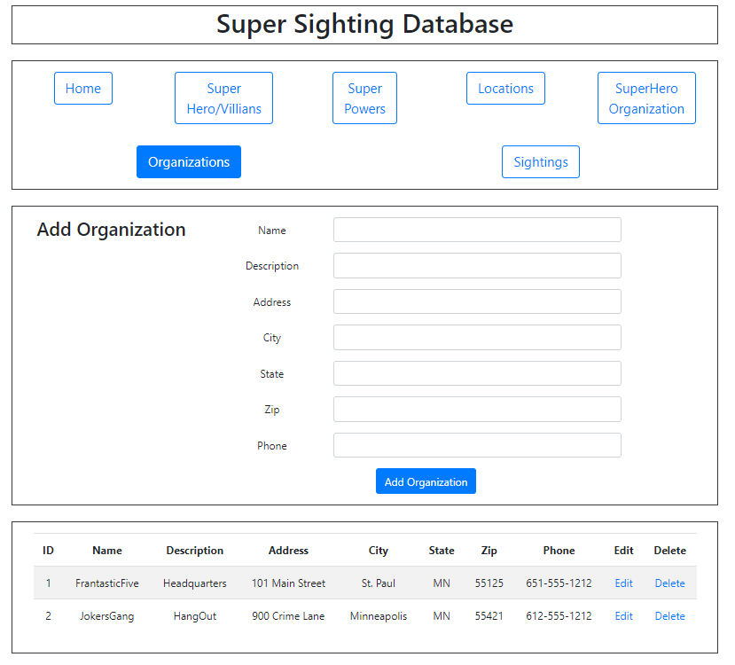

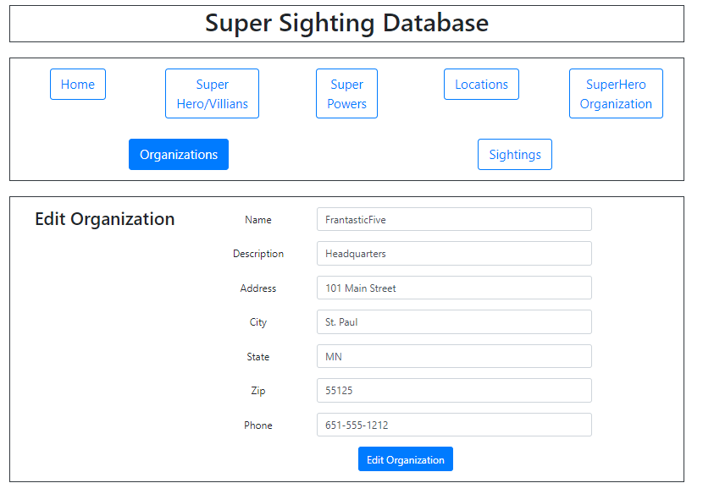

# Sightings and Edit Screen

